**Storywalk® is Coming!!**

The Texas State Library and Archives Commission (TSLAC) recently awarded funding to Cross Plains Public Libraryunder its Texas Reads grant program for the installation of Storywalk®. Storywalk® allows children — and adults! — to enjoy reading and the outdoors together. Pages from a children's book are inserted in frames, attached to posts, and installed along an outdoor path. As you stroll down the trail, you encounter the next page in the story.

This project is a partnership between the City of Cross Plains, the Cross Plains Garden Club, Cross Plains Elementary School, and the library. Our Storywalk® will be installed along the path in the Community Center Park and will contain 16 stations featuring pages from children’s books. Books are being chosen by the 1st, 2nd, 3rd, and 4th grade classes and their choices will be installed every two months throughout the school year. Stations should arrive in mid-October and an unveiling will be held soon after.

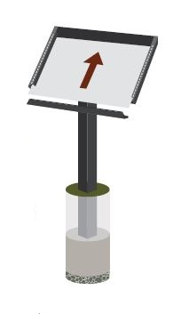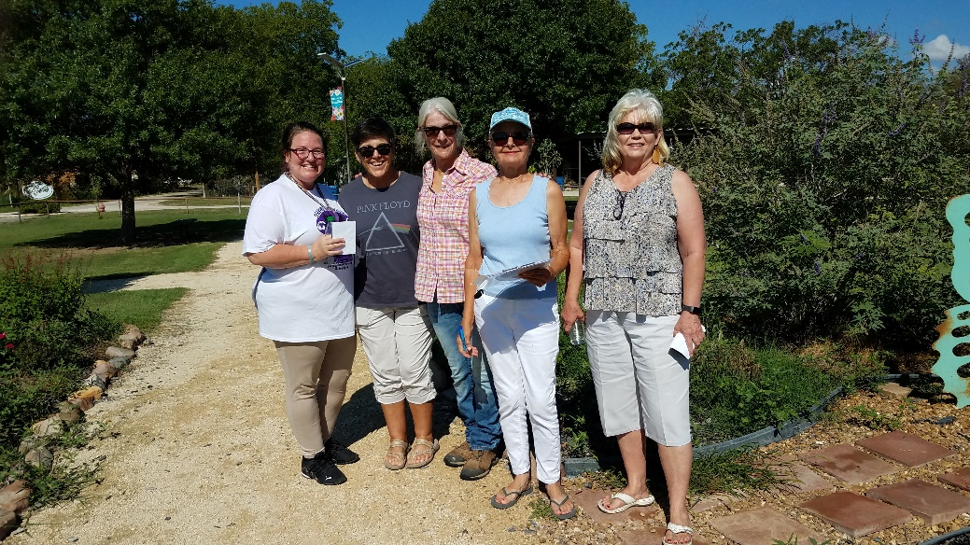

After reviewing placement of Storywalk® in the Community Center Park, team members stop and enjoy the beauty of the butterfly gardens. Pictured (L-R) are Cross Plains Library Director Debbie Box and Board President Jan Bond, Cross Plains Garden Club members Linda Balise and Diana Miller, and City Administrator Debbie Gosnell.

“We are so thrilled that Storywalk® is coming to our community.  Patrons will be able to enjoy the gardens and read the books with their children and grandchildren when it is convenient for them and not be limited to the library’s business hours,” said Library Board President Jan Bond.

City Administrator Debbie Gosnell stated “Cross Plains has been fortunate enough to obtain two grants to help update our Community Center Park.  In collaboration with the Garden Club who have been instrumental in the design and development of the flower garden we have been able to install eleven native flower beds all of which attract the monarch butterflies.  As one of the finishing touches, our local Cross Plains Public Library will furnish the “Storywalk®” project, which will be such a beautiful addition to the walking path and very educational for our young visitors. Cross Plains is fortunate to have organizations that come together to promote the betterment of our little community.”

*This project is just one of 43 made possible this year by a grant from the U.S. Institute of Museum and Library Services to the Texas State Library and Archives Commission under the provisions of the Library Services and Technology Act. (Grant # LS-252486-OLS-22.)*

*The Storywalk® Project was created by Anne Ferguson of Montpelier, VT and developed in collaboration with the Kellogg-Hubbard Library.  Storywalk® is a registered service mark owned by Ms. Ferguson.*